§6.1 Angle Measure

Initial Side – The ray that begins the rotation to create an angle

Terminal Side – The ray that represents where the rotation of the initial side stopped

Angle – Two rays with a common endpoint ∠ABC

Positive – An angle created by the initial side rotating counterclockwise

Negative – An angle created by the initial side rotating clockwise

What is a Radian?
If an ∠θ is drawn in standard position with a radius, r, of 1, then the arc, s, subtended by the rotation of the ray will measure 1 radian (radian measure was the t measure that we used in Chapter 5 btw)
r = s = 1 radian
r
θ

This means that for any angle, θ, θ = ^{s}/_{r}

Note: A radian is approximately equal to 57.296º and 1º ≈ 0.01745 radians. Don’t use approximations to do conversions!

Why Radians?
∠ 's are not real numbers and radians are, so with radian measure the trig function has a domain with a real number.

Converting
Because the distance around an entire circle, C= 2πr and C is the arc length of the circle this means the ∠ corresponding to the ∠ swept out by a circle is equivalent to 2π times the radius:

360º = 2π(radius) thus
π radians = 180º
So, 1° = ^{π}/₁₈₀ Multiply the degree measure by ^{π}/₁₈₀
or
1 radian = ¹⁸⁰/π Multiply the radian measure by ¹⁸⁰/_{π}; or just substitute 180º for π

Example: Convert to Radians
a) 108° b) 325.7° c) -135° d) 540°

Example: Convert to Degrees
a) ^{11π}/₁₂ b) -^{7π}/₆ c) -2.92

Using your calculator to check:

Deg ► Rad
- Set Mode to Radians [2nd][MODE]
- Enter # [2nd][APPS] [1]
- Gives decimal approximation Enter (#)
Rad ► Deg
- Set Mode to Degree [2nd][MODE]
- [2nd][APPS] [3] [2nd] [APPS] [4]

Converting between Radian and Degree Measure is extremely important and having a copy of the unit circle broken into equivalent measure is nice.
^{π/}₄; (^{√2}/₂, ^{√2}/₂)
^{π/}₆; (^{√3}/₂, ¹/₂)
^{π/}₃; (¹/₂, ^{√3}/₂)
^{3 π/}₄; (-^{√2}/₂, ^{√2}/₂)
^{5π/}₆; (-^{√3}/₂, ¹/₂)
^{2π/}₃; (-¹/₂, ^{√3}/₂)
^{4 π/}₃; (-¹/₂, -^{√3}/₂)
^{5π/}₃; (¹/₂, -^{√3}/₂)
^{5 π/}₄; (-^{√2}/₂, -^{√2}/₂)
^{7π/}₄; (^{√2}/₂, -^{√2}/₂)
^{11π/}₆; (^{√3}/₂, -¹/₂)
^{7π/}₆; (-^{√3}/₂, -¹/₂)
^{π/}₂;
(0, 1)
π; (-1, 0)
0; (1, 0)
^{3π/}₂;
(0, -1)

Note 1: Make all 45° marks by 4ths and make all 30º/60º marks by 6ths and count your way around.
Note 2: Think in terms of x-axis and ^{π}/₆=30°, ^{π}/₄=45°, and ^{π}/₃=60° adding and subtracting your way around the circle 2π.

Now, we'll pick up where we left off in Chapter 5. Convert from radian to degree to see coterminal and reference ∠ 's = 45º, 30º, 60.

Coterminal Angles – Angles that differ by a measure of 2π or 360º. Find by θ + n•360º or s + n•2π. Coterminal angles can be positive or negative, and can be found by using
n ∈ I.

Example: Find an angle that is between 0º and 360º that is coterminal with the one
given. Note: Another way of saying this is, “Find the measure of the least possible
positive measure coterminal angle.”
(Hint: “+” add/subt. mult. of 360º/2π to get ∠between 0º & 360º/0 & 2π
“−” less than 360º/2π use a rotation (add 360º/2π)
“−” greater than 360º/2π find next mult. bigger than & add)
a) 1106º b) -150º c) -603º

c) ^{13π}/₄ d) ^{-7π}/₆ e) ^{-28π}/₃

Example: Give 2 positive & 2 negative angles that are coterminal with 75º
(Hint: θ + n•360º)

Example: Give 2 positive & 2 negative angles that are coterminal with ^{7π}/₈
(Hint: s + n•2π)

Arc Length - s
If θ = ^{s}/_{r} then s = rθ, if θ is in radians.

Note: If θ is in degrees us ^{θπ}/₁₈₀ for the shift to radians.

Example: A circle has a radius of 25.60cm. Find the length of an arc that subtends a central∠ having the following measures.
a) ^{7π}/₈ rad b) 54°

Note: Your book typically keeps the values in terms of π. Watch significant digits if you round.

Applications of arc length can be far reaching from distances around the globe (arc length) to cable or rope around a pulley to gear ratios. Let's look a one each of the above mentioned examples.
Example: Erie, PA is approximately due north of Columbia, SC. The latitude of
Erie is 42°N and Columbia is 34°N. Find the distance between the 2
cities.
*Trigonometry, 9th ed., Lial, Hornsby & Schneider
- Draw a picture
- Find difference in ∠ 's to get ∠ between and convert to radians
- s = θr

Note 1: The radius of the Earth is 3960mi (6400km). Your book uses miles

Example: A cord is wrapped around a top with radius 0.327m and the top is spun
through a 132.6° angle. How much cord will be wound around the top?
*Trigonometry, 9th ed., Lial, Hornsby & Schneider
- Draw a picture.
- Deg ► Rad
- s = θr
- Significant Digits (should be 3 because the smallest number of significant digits is 3.)

Example: Two gears move together so that the smaller gear with radius of 3.6 in
drives the larger one with a radius of 5.4 in. If the smaller gear rotates
through 150°, how many degrees will the larger gear rotate?
*Trigonometry, 9th ed., Lial, Hornsby & Schneider
- Draw a picture.
- s for smaller gear = s for larger gear.
- Use this relationship to find θ = ^{s}/_{r}

Area of a Sector of a Circle
Since the area of a circle is πr² and the portion (sector) of a circle makes up ^{θ}/_{2π} then:

Area = A = (^{θ}/_{2π})(πr²) or θ r² (where θ is in radians)
2

Example: Find the area of a sector of a circle having radius 15.20 ft and a central
∠ of 108.0°. *Trigonometry, 9th ed., Lial, Hornsby & Schneider

Note: The nearest tenth of a degree is considered to be 3 significant digits and 15.20 is 2 significant digits. Two significant digits is therefor the correct round off for this problem.
Linear Speed
Linear Speed = v
Distance = s
Time = t
Since D = rt and r is the velocity and distance is the arc length, s
v = ^{s}/_{t} = ^{rθ}/_{t}

Linear speed is how fast a point is moving around the circumference of a circle (how fast it's position is changing. Important in Calculus and Physics.).

Angular Speed
Angular Speed = ω ; units are radians per unit time
Αngle with relation to terminal side and ray OP = θ rad
Time = t
ω = ^{θ}/_{t}

Angular speed is how fast the angle formed by the movement of point P around the circumference is changing (how fast an angle is formed).

Now we can make some substitutions into these equations based on Section 6.1’s definition of an arc and get equivalent statements.

Since s = θr we can substitute into v = ^{s}/_{t} and find v = ^{rθ}/_{t} but ^{θ}/_{t} = w so
v = r ω

Example: Suppose that P is on a circle with a radius of 15 in. and a ray OP is rotated
with angular speed ^{π}/₂ ^{rad}/_{sec}. *Trigonometry, 9th ed., Lial, Hornsby & Schneider

a) Find the angle generated by P in 10 second.
Step 1: List info that you have & what you need to find

Step 2: Decide on the formula needed to find

Step 3: Solve

b) Find the distance traveled by P along circle in 10 seconds.

c) Find linear speed of P in ^{in}/_{sec}.

Now, we'll take this knowledge and apply it to circular things that move like bicycle wheels, fly wheels, pulleys, satellite, and points on the earths surface.
Example: Find the linear speed of a point on a fly wheel of radius 7 cm if the fly
wheel is rotating 90 times per second.
*Trigonometry, 9th ed., Lial, Hornsby & Schneider
Step 1: Find the angular speed. You know the revolutions per second, and you know how many
radians per revolution, so multiplying these facts will give the angular speed in radians per
second.

Step 2: Use the appropriate formula to find linear speed.

Example: Find the linear speed of a person riding a Ferris wheel in ^{mi}/_{hr} whose radius is 25 feet if it takes 30 seconds to turn ^{5π}/₆ radians.
*Trigonometry, 9th ed., Lial, Hornsby & Schneider
Step 1: List info that you have & what you need to find

Step 2: Decide on the formula needed to find

Step 3: Solve

Step 4: Convert to mph from ^{ft}/_{sec}
§6.2 Trigonometry of Right Triangles

I’ve already introduced the concepts in this section §5.2. Let’s review the trig ratios in terms of opposite, adjacent and hypotenuse.
θ
“y” is opposite
“x” is adjacent
“r” is hypotenuse
r = √ x² + y² (Pythagorean Theorem)
r > 0 since it is a distance
(an undirected vector meaning it has no direction)
P (x, y)
sin θ = opp = y Note: When r = 1, sin θ = y
hyp r

cos θ = adj = x Note: When r = 1, cos θ = x
hyp r

tan θ = opp = sin θ = y x ≠ 0
adj cos θ x

cot θ = adj = 1 = cos θ = x y ≠ 0
opp tan θ sin θ y

sec θ = hyp = 1 = r x ≠ 0
adj cos θ x

csc θ = hyp = 1 = r y ≠ 0
opp sin θ y

*Note: I have also heard students use the acronym SOHCAHTOA to help them remember the ratios. SOH meaning Sine is opposite over hypotenuse. CAH meaning cosine is adjacent over hypotenuse. TOA meaning tangent is opposite over adjacent.

We can use these definitions to find the values of the 6 trig functions for an angle, θ. Also recall our 2 special triangles the 30/60/90 and the 45/45/90 and that regardless of the actual lengths of the sides, the sides will remain in the same ratio to one another when the angles are the same.
45/45/90 Right ∆
√2
1
1
45º
45º
30/60/90 Right ∆
60°
30°
√3
1
2

θ | s | sin | cos | tan | cot | sec | csc
30° | ^{π}/₆ | ¹/₂ | ^{√3}/₂ | ^{√3}/₃ | √3 | ^{2√3}/₃ | 2
45° | ^{π}/₂ | ^{√2}/₂ | ^{√2}/₂ | 1 | 1 | √2 | √2
60° | ^{π}/₃ | ^{√3}/₂ | ¹/₂ | √3 | ^{√3}/₃ | 2 | ^{2√3}/₃
*Remember my order and the order of your book are not the same. Your book’s order goes: sin, cos, tan, csc, sec, cot. This is only important if you have strong pattern recognition tendencies in your learning style.

Solving Right ∆’s

Solving When 2 Sides Known
Step 1: Sketch & decide on trig f(n) that fits scenario
Step 2: Solve for the other side if asked (Pythagorean Thm)
Step 3: Set up trig def w/ 2 sides
Step 4: Solve using inverse sin/cos/tan of the ratio in step 3
Step 5: Round using significant digits

Example: Find the 6 trig functions for α and β, then find the value of α and β to
correct to 5 decimals.
α
β
4
7
*Precalculus, 5th ed., Stewart, Redlin & Watson p. 484 #8

Not only can we use our skills to find the exact values of the angles, but we can also use our skills combined with a calculator to find the approximate value of a side. Note that if it is possible to give an exact value of a side because it is a special triangle you should always give the exact value. When we must approximate your book is using 5 decimal places (notice that this is not the same as 5 significant digits).

Solving Right ∆’s

Solving When 1 side & 1 angle known
Step 1: Sketch & decide on trig f(n) that fits scenario
Step 2: Solve for the other angle if asked – (90 – ∠)
Step 3: Set up trig def. w/ known ∠   & side &   unknown
Note: opp = r sin θ & adj = r cos θ
Step 4: Solve equation in step 3
Step 5: Round using significant digits

Example: Find the value of the missing angle, β, and the length
of the other 2 sides. Approximate the side lengths to
75º
β
100
the nearest tenth of a unit when necessary.
*Precalculus, 5th ed., Stewart, Redlin & Watson p. 484 #30

Note: You will accrue too much round-off error if you use your approximate value from hyp = ^{adj}/_{cos β} with the Pythagorean Theorem to determine a value for the opposite. You should use a different trig function or use the expression ^{adj}/_{cos} itself to calculate.
Angles of Elevation/Depression
An angle of elevation/depression is defined as the angle from line of sight (parallel to the horizon line) to an object. This is never greater than 90°.
∠ of depression
Horizon
object
Horizon
∠ of elevation
object

To figure out ∠’s of depression, it may help to look at the following diagram:
∠ of Depression
∠ of Elevation
Horizon Line at Point X
Horizon Line at Point Y
Sight Line
Y
X

The angle of depression from Y to X is the same as the angle of elevation from X to Y, since they are alternate interior angles! Recall your knowledge of Geometry for alternate interior angles being equal.

Example: The angle of depression from the top of a tree to a point on the ground
15.5 m from the base of the tree is 60.4°. Find the height of the tree.
*Trigonometry, 9th ed., Lial, Hornsby & Schneider

Example: The length of a shadow of a flagpole 55.2 ft. tall is 27.65 ft. Find the
angle of elevation of the sun.
*Trigonometry, 9th ed., Lial, Hornsby & Schneider

Note: Don’t forget to watch the number of significant digits. This problem has 3 and 4 significant digits in it!
Example: The angle of elevation from the top of a small building to the top of a
nearby taller building is 46 ²/₃º, while the angle of depression to the
bottom of is 14 ¹/₆º. If the shorter building is 28.0 m high, find the height
of the taller building.
*Trigonometry, 9th ed., Lial, Hornsby & Schneider, #53 p. 82

28 m
46 ²/₃º
14 ¹/₆º
x

§6.3 Trigonometric Functions of Angles

This section continues with the idea developed in Chapter 5. The reference angle, then called a reference number and its use in finding the values of trig functions of non-acute angles. Let’s review the idea of a reference angle, with the new terminology.

Reference Α– An angle, θ-bar, is a positive angle less than 90º or ^{π}/₂ (an acute angle) made by the terminal side and the x-axis.
θ = θ-bar
QI θ = θ-bar

θ
θ-bar
QII θ-bar = π – θ
θ
θ-bar
QIII θ-bar = θ – π
θ-bar
θ
QIV θ-bar = 2π – θ

For θ > 2π or for θ < 0, divide the numerator by the denominator and use the remainder over the denominator as t. You may then have to apply the above methodologies of finding θ-bar.

Also recall our handy way of using the quadrants to give us the value of trig functions based upon the quadrant.
QI
x, y & r > 0
QII
x < 0, y & r > 0
QIII
x & y < 0 , r > 0
QIV
x & r > 0 , y < 0
x
y
All F(n) “+”
Sin & csc “+”
Cos & sec “+”
Tan & cot “+”
This Saying Will Help Remember the Positive F(n)
AllAll f(n) “+”
Studentssin & csc “+”
Taketan & cot “+”
Calculuscos & sec “+”

Example: Find the exact value of the following by using a reference angle.
a) θ = 150º b) θ = 210º

c) θ = 660º d) θ= -315º
Also recall our work with the trigonometric identities.

Reciprocal Identities Pythagorean Identities

tan t = sin t
cos t

cot t = 1 = cos t
tan t sin t

sec t = 1
cos t

csc t = 1
sin t

sin² θ + cos² θ = 1 or cos² θ = 1 – sin² θ

tan² θ + 1 = sec² θ

1 + cot² θ = csc² θ

As in §5.2 we found one trig function in terms of another in a general sense and we also used identities to find the values of trig functions. Exercises like #39-52 use these skills.

Example: Use cot θ to write csc θ in QIII. (#44 p. 460, Precalculus, 6th ed, Stewart)

Example: Find the value of tan θ if sec θ = 5 when sin θ < 0.
(Like #48 p. 460, p. 460, , Precalculus, 6th ed, Stewart)

Last, we can find the area of a triangle, using trigonometry as well. I won’t prove this here, but it follows quite simply from the Law of Sines and the area of a triangle. We will study the Law of Sines in §6.5.
Area of a Triangle
a
b
θ
A = ¹/₂ ab sin θ

θ is the ∠ angle include within sides a & b

9 in.
12 in.
127º
Example: Find the area of the triangle shown.
§6.4 Inverse Trig F(n) and Right Triangles &
§5.5 Inverse Trig f(n) and Their Graphs
Note: In Edition 5 both sections together comprise §7.4

First let’s review relations, functions and one-to-one functions.

A relation is any set of ordered pairs. A relation can be shown as a set, a graph or a function (equation).

a) {(2,5), (2,6), (2,7)}
b) y = √x, {x| x ≥ 0, x∈ℜ}
c)
15
-15
5
-5
x

A function is a relation which satisfies the condition that for each of its independent values (x-values; domain values) there is only 1 dependent value (y-value; f(x) value; range value).

From above, only b) y = √x, {x| x ≥ 0, x∈ℜ}
satisfies this requirement

Note: We can check to see if a relation is a f(n) by seeing if any of the x’s are repeated & go to different y’s; on a graph a relation must pass vertical line test and if it’s a f(n)/equation then you can think about it in terms of the domain and range or in terms of its graph.

A one-to-one function is a function that satisfies the condition that each element in its range is used only once (has a unique x-value; domain value).

From above, only b) y = √x, {x| x ≥ 0, x∈ℜ}
satisfies this requirement

Note: We can check to see if a function is 1:1 by seeing if any of the y’s are repeated & go to different x’s; on a graph a 1:1 f(n) must pass horizontal line test and if it’s a f(n)/equation then you can think about it in terms of the domain and range or in terms of its graph.

If you remember from your study of Algebra, we care about one-to-one functions because they have an inverse. The inverse of a function, written f⁻¹(x), is the function for which the domain and range of the original function f(x) have been reversed. The composite of an inverse and the original function is always equal to x.
Inverse of f(x)
f ⁻¹(x) = {(y, x) | (x, y) ∈ f(x)}

Note: f ⁻¹(x) is not the reciprocal of f(x) but the notation used for an inverse function!! The same will be true with our trigonometric functions.

Facts About Inverse Functions
1) Function must be 1:1 for an inverse to exist; we will sometimes restrict the
domain of the original function, so this is true, but only if the range is not
effected. Note: You will see this with the trig functions because they are not 1:1 without
the restriction on the domain.
2) (x, y) for f(x) is (y, x) for f ⁻¹(x)
3) f(x) and f ⁻¹(x) are reflections across the y = x line
4) The composite of f(x) with f ⁻¹(x) or f ⁻¹(x) with f(x) is the same; it is x
5) The inverse of a function can be found by changing the x and y and solving for y
and then replacing y with f ⁻¹(x). Note: This isn’t that important for our needs here.

What you should take away from the above list is:
1) We make the trig functions one-to-one by restricting their domains
2) (x, y) is (y, x) for the inverse function means that if we have the value of the trig
function, the y, the inverse will find the angle that gives that value, the x
3) When we graph the inverse functions we will see their relationship to the graphs
of the corresponding trig function as a reflection across y = x.
4) sin ⁻¹ (sin x) is x
Note: You might use this one in your Calculus class.

The Inverse Sine – Also called the ArcSin
If f(x) = sin x on D: [-^{π}/₂, ^{π}/₂] & R: [-1, 1]
Notice: Restriction to the original domain is to QI & QIV of
unit circle!

then f ⁻¹(x) = sin⁻¹ x or f ⁻¹(x) = arcsin x on D: [-1, 1] & R: [-^{π}/₂, ^{π}/₂]
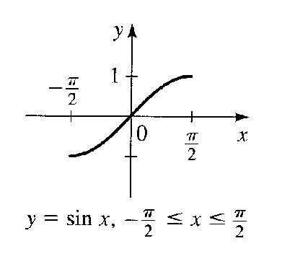
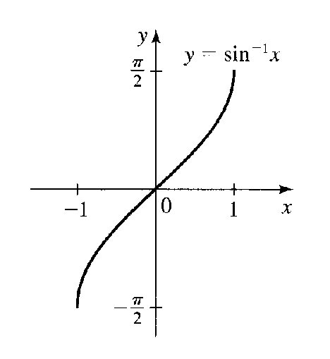
Note: Scan from p. 551 Stewart ed 5
Note: Scan from p. 551 Stewart ed 5
Finding y = arcsin x
1) Think of arcsin as finding the x-value (the radian measure or degree measure of the angle)
of sin that will give the value of the argument.
Rewrite y = arcsin x to sin y = x where y = ? if it helps.
2) Think of your triangles! What ∠ are you seeing the opposite over hypotenuse
for?

Example: Find the exact value for y without a calculator. Don’t forget to check domains!
Use radian measure to give the angle.
a) y = arcsin ^{√3}/₂ b) y = sin ⁻¹ (⁻¹/₂) c) y = sin ⁻¹ √2

However, it is not always possible to use our prior experience with special triangles to find the inverse. Sometimes we will need to use the calculator to find the inverse.

Example: Find the value of the following in radians rounded to 5 decimals
*Precalculus, 6th ed., Stewart, Redlin & Watson p. 467 #10
y = sin ⁻¹ (¹/₃)

The Inverse Cosine – Also called the ArcCos
If f(x) = cos x on D: [0, π] & R: [-1, 1]
Notice: Restriction to the original domain is to QI & QII of
unit circle!

then f ⁻¹(x) = cos⁻¹ x or f ⁻¹(x) = arccos x on D: [-1, 1] & R: [0, π]

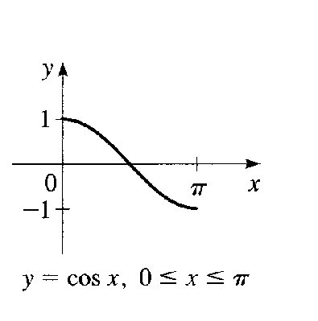
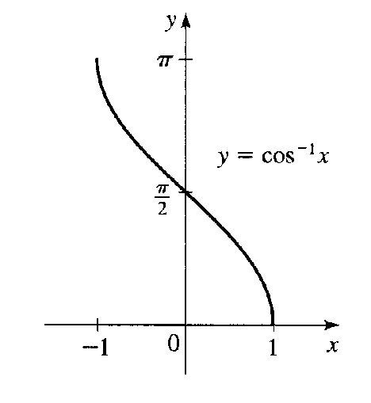
Note: Scan from p. 553 Stewart ed 5
Note: Scan from p. 553 Stewart ed 5

Example: Find the exact value of y for each of the following in radians.
a) y = arccos 0 b) y = cos ⁻¹ (¹/₂)

Example: Find the value of the following in radians rounded to 5 decimals
*Precalculus, 6th ed., Stewart, Redlin & Watson p. 467 #8
y = cos⁻¹ (-0.75)

The Inverse Tangent – Also called the ArcTan
If f(x) = tan x on D: [^{-π}/₂, ^{π}/₂] & R: [-∞, ∞]
Notice: Restriction to the original domain is to QI & QIV of
unit circle!

then f ⁻¹(x) = tan⁻¹ x or f ⁻¹(x) = arctan x on D: [-∞, ∞] & R: [^{-π}/₂, ^{π}/₂]

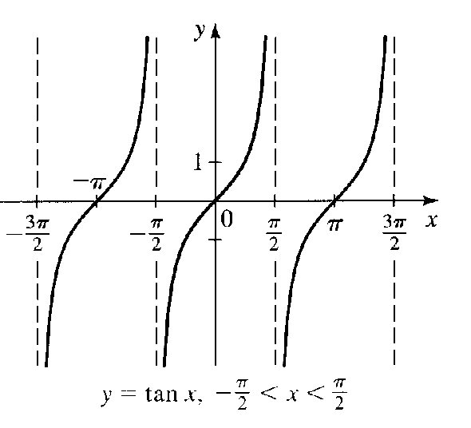
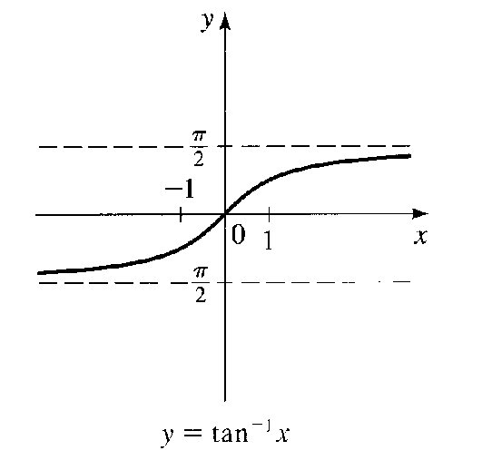
Note: Scan from p. 555 Stewart ed 5
Note: Scan from p. 555 Stewart ed 5

Notice: The inverse tangent has horizontal asymptotes at ±^{π}/₂. It might be interesting to note that the inverse tangent is also an odd function (recall that tan (-x) = -tan x and also the arctan (-x) = - arctan (x)) just as the tangent is and that both the x & y intercepts are zero as well as both functions being increasing functions.

Example: Find the exact value for y, in radians without a calculator.
y = arctan √3

I am not going to spend a great deal of time talking about the other 3 inverse trig functions in class or quizzing/testing your graphing skills for these trig functions. I do expect you to know their domains and ranges and how to find exact and approximate values for these functions.

Summary of Sec⁻¹, Csc⁻¹ and Cot⁻¹
Inverse Function | Domain | Interval | Quadrant on Unit Circle
y = cot⁻¹ x | (-∞, ∞) | (0, π) | I & II
y = sec⁻¹ x | (-∞,-1]∪[1,∞) | [0, π], y≠^{π}/₂ | I & II
y = csc⁻¹ x | (-∞,-1]∪[1,∞) | [-^{π}/₂, ^{π}/₂], y≠0 | I & IV
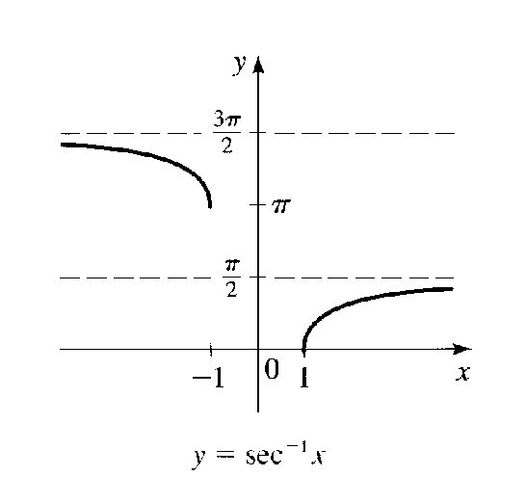
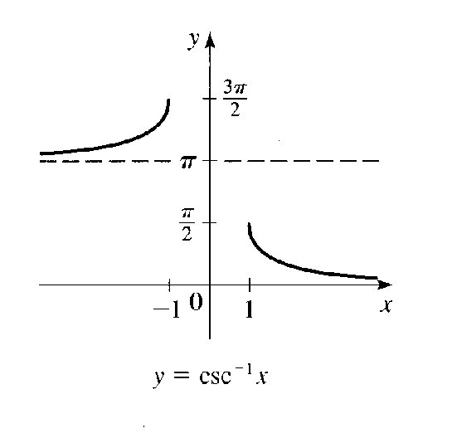
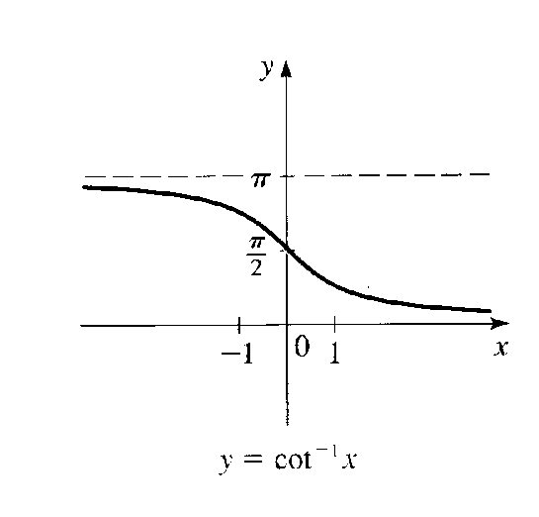

Example: Find the exact value for y, in radians without a calculator.
y = arccsc -√2

Before we do any examples that require the use of our calculator to find the inverse of these functions, it is important that you recall your reciprocal identities! It is by using these reciprocal identities first that you can find the inverse values on your calculator. Let me show you an example first.

Example: Find the approximate value in radians rounded to the nearest 5 decimals.
y = sec⁻¹ (-4)
STEP 1: Rewrite as secant sec y = -4
STEP 2: Rewrite both sides by taking the reciprocal ¹/_{sec y} = ⁻¹/₄
STEP 3: Use reciprocal identity to rewrite cos y = ⁻¹/₄
STEP 4: Find the inverse of both sides to solve for y
cos⁻¹(cos y) = cos⁻¹ (⁻¹/₄)
STEP 5: Use your calculator to find y = cos⁻¹ (⁻¹/₄)

Example: Find the approximate value in radians rounded to the nearest 5 decimals.
y = arccot (-0.2528)

We can also “take a page” from the skill-set that we have just been using and use it to solve a little more difficult problems – those that deal with the composite of trig and inverse trig functions. In these type of problems we will work from the inside out. We don’t actually ever get a degree measure from these problems, because the final answer is actually the ratio of sides.
1) We will use the inside function to put together a triangle
2) Then we use the Pythagorean Theorem to find the missing side
3) Finally, we use the definitions of the trig functions based upon opposite, adjacent
and hypotenuse lengths to answer the problem.

Example: Evaluate each of the following without a calculator
a) cos (sin⁻¹ ²/₃) b) sec (cot⁻¹ (⁻¹⁵/₈))

Note that I have only given examples that deal with radians, but there are also problems that ask for the answers in degrees. Practice both and remember when it comes to applications that involve arc length the use of radians is necessary. See #42 p. 468 of edition 6 for example.
Let’s do an application problem that will remind us of our previous instruction on angles of elevation.
θ
96 ft.
120 ft.
Example: Find the angle of elevation of the sun.
*Precalculus, 6th ed., Stewart, Redlin & Watson
p. 468 #38

If we have time I may talk about problem #42 from the 6th edition as well.
§6.5 The Law of Sines (Note §6.4 in Ed. 5)

First we need the definition for an oblique triangle. This is nothing but a triangle that is not a right triangle. In other words, all angles in the triangle are not of a measure of 90º. These are the type of triangle that are of interest to us in the application of the Law of Sines and Law of Cosines.

Next, let’s review the naming convention of triangles (from your study of Geometry, hopefully). The angles are name with capital letters. The sides opposite an angle are named with the comparable lower case letter.
a
b
C
c
A
B

Now, we need to refresh our memory of some axioms from Geometry.

Congruency Axioms (Methods to establish congruency.)
SAS: Side Angle Side 2 sides known w/ included angle
ASA: Angle Side Angle 2 angles known w/ included or non-included side
(AAS non-included side)
SSS: Side Side Side 3 sides known
Note: We will always need at least 1 side to have congruency.

It is with these axioms that we will use the Law of Sines and Law of Cosines which are the methods for solving oblique triangles.

There are a total of 4 cases for using the Law of Sines or Law of Cosines. They are as follows:
CASE 1: When we know one side and 2 angles. (SAA and ASA)
CASE 2: When two sides and one angle are known. (SSA—Ambiguous Case and SAS)
*CASE 3: When two sides and 1 included angle are known. (SAS)
*CASE 4: When three sides are known. (SSS)
*We will see these cases in the next section using the Law of Cosines.

sin A = sin B = sin C OR a = b = c
a b c sin A sin B sin C

Where A, B & C are angles in an oblique triangle and a, b & c are the sides opposite the angles.
The above stated is called the Law of Sines. When solving a triangle using the Law of Sines, any two of the equivalent ratios will do and chose the relation that puts your unknown in the numerator for your own sanity.
28.8º
a
b
C
c = 25.3 in.
A
B
102.6º
Example: Solve the following triangle.

Is this a SAA, ASA or SSA or SAS? Do you need to worry about ambiguity?

Example: Seinfeld wants to measure the distance across the Hudson River (B
to C). If he stands at point A he is 75.6 ft. from point C, on the
Hudson’s near bank. The angle of BCA is 117.2º and BAC is
28.8º. Refer to the diagram below.
A
B
C
b = 75.6 ft.

What is this case? Is there any ambiguity?

Bearing is something that is applied in some of our problems. Bearing is the angle from a forementioned pole in a horizontal direction. For example the following bearing can be interpreted in the drawing below. Example: N 52º W
N 52º W

Example: The bearing of a lighthouse from a ship is N 52º W. After sailing
5.8 km due south the bearing from the ship to the lighthouse is
N 23º W Find the distance of the ship from the lighthouse in each
location.

Again, what case is this? Is there any ambiguity?

Now we will talk about the ambiguous case of the Law of Sines. When we know SSA, there are 4 possibilities – there may be no such triangle as shown in the 1st picture below, a right triangle (the 2nd picture), two such triangles (the 3rd picture) or one unique triangle. I’m just going to take a scan of the possibilities and put them in here because the time it would take to draw them would not be worth my while. You can find further discussion on p. 503 of Ed 5 & p. 471 of Ed 6.

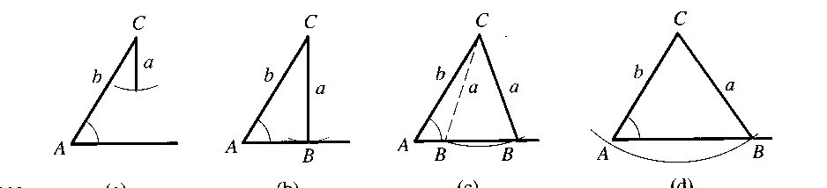

Note: One of the checks to see if we have a second possible solution is to see if sin A < 1. If if is then we need to check and can eliminate only if the sum of the angles is > 180º. Likewise if sin A ≥ 1 there is no solution.

Here is a summary of information that may be helpful in solving the Ambiguous Case of Sines.
Facts in Applying The Law of Sines
1) For any ∠ in a ∆ sin θ is in (0, 1].
2) When sin θ = 1, θ = 90º and the triangle must be a right ∆. If another angle is ≥
90º then it is an ambiguous case.
3) sin θ = sin (180 – θ); In other words, supplementary angles have the same sines
It is this equality that gives us the 2 possible triangles based on the same sine
4) Smallest Angle opposite shortest side
Medium Angle opposite medium side
Largest Angle opposite largest side
In triangles that aren’t isosceles or equilateral

Example: Solve ∆ABC if a = 17.9cm, c = 13.2 cm & C = 75.5º

Note: The sin A is larger than one so this is not possible.

Example: Solve ∆ABC if A = 61.4º, a = 35.5 cm & b = 39.2cm

Note: Note that Given < B and in this case you should check 180º – B as a second solution.

Example: Solve ∆ABC, given B = 68.7º, b = 25.4 in.& a = 19.6 in.

Note: Note Given > A & checking further you will see that the supplementary angle to A + B will be > 180 so a second angle can’t exist.

Example: Explain why no triangle ABC exists for the following
B = 93º, b = 42 cm and c = 48 cm

Note: See the last of my 4 notes above.

In Summary Proceeding w/ the Ambiguous Case
1) If the sine of the unknown angle is > 1 then no triangle exists

2) If sine of the unknown angle is = 1 then exactly one triangle exists and it is a right
triangle.

3) If the sine is between 0 & 1 then 1 or 2 triangles exist
a) Find the angle for the 1st triangle
b) Find the supplement of the angle. If original angle + supplement is < 180
then a second triangle exists and you should find it.

§6.6 The Law of Cosines

The Law of Cosines is used to solve a triangle under the last 2 cases we studied in the last section.
*CASE 3: When two sides and 1 included angle are known. (SAS)
*CASE 4: When three sides are known. (SSS)
An important fact to remember is that the sum of 2 sides is never greater than the 3rd side. If any of the following hold then a ∆ DNE:
a + b > c a + c > b b + c > a

Law of Cosines

a² = b² + c² – 2bc cos A
b² = a² + c² – 2ac cos B
c² = a² + b² – 2ab cos C

Note: The side on the left side is the ∠ for which you take the cosine & the other 2 sides are multipliers of twice the cosine.

If you wish to see the Law of Cosines proven please refer to p. 509 of Ed 5 & p. of Ed 6. The long and short of it is that we place the oblique triangle in the coordinate system and use the distance formula and trig to get the coordinates of the terminal point in the coordinate system.

Example: Two boats leave a harbor at the same time, traveling on courses
that make an angle of 82 ¹/₃º between them. When the slower has traveled
62.5 km, the faster one has traveled 79.4 km. What’s the distance between the
boats?

SAS Case
1) Plug into Law of Cosines appropriately to find the 3rd side
2) Find the missing ∠ using the Law of Sines

Example: Solve the ∆ABC if B = 73.5º, a = 28.2ft. & c = 46.7 ft.
Step 1: Use Law of Cosines to get b
Step 2: Use Law of Sines to get ∠A&C
Step 3: Subtract to get other ∠

SSS Case
1) Use Law of Cosines to find 1 angle
2) Use Law of Cosines or Law of Sines to find 2nd angle
3) Subtract to get 3rd angle

Example: Solve ABC if a = 25.4 ft, b = 42.8 ft. & c = 59.3ft.

Note: The Law of Sines does lead to the ambiguous case 61.4º, but we know it can’t be, because sin C is opposite the larger side and that would make side b the largest side since it would be the largest angle.
a = 9 ft.
b = 6ft.
C
c = 11 ft.
A
B

Example: Find ∠A

We can find the area of a triangle using Heron’s Formula which is based on the Law of Sines. See the proof on p. 512 of Ed 5 & p. 479 of Ed 6 of your book. I will not prove it here.

Heron’s Formula

A = √s(s – a)(s – b)(s – c)

Where s = ¹/₂(a + b + c) & a, b &c are the side lengths

Note: This works for SAS triangles only. If the included angle is 90º this is simply our familiar area formula since sin 90º is 1 and the two sides surrounding it are then the base and the height.

Example: Use Heron’s formula to find the area of the triangle shown below.
a = 9 ft.
b =12 ft.
C
c
A
B
127º

Example: Find the area of ∆ABC if B = 58 ¹/₆ º, a = 32.5 cm and C = 73 ¹/₂º

