Preface to Chapter 5
The following are some definitions that I think will help in the acquisition of the material in the first few chapters that we will be studying. I will not go over these in class and will assume that you know them, so it is in your best interest to review the information that I am giving you.

Definitions Associated w/ Lines Notation Visualization
Ray – Portion of a line from point A thru B Ray AB

Endpoint of Ray – The point from which a ray begins

Definitions Associated w/ Angles Notation Visualization
Angle – Two rays with a common endpoint ∠ABC

Vertex – The point in common with the rays

Initial Side – The ray that begins the rotation to create an angle

Terminal Side – The ray that represents where the rotation of the initial side stopped

Positive – An angle created by the initial side rotating counterclockwise

Negative – An angle created by the initial side rotating clockwise

Acute – An angle measuring less than ^{π}/₂ = 90º

Right – An angle measuring exactly ^{π}/₂ = 90º

Obtuse – An angle greater than ^{π}/₂ = 90º but less than π =180º

Straight – An angle measuring exactly π =180º

Complementary – Two positive measure angles that sum to 90º

Supplementary – Two positive measure angles that sum to 180º

Standard Position – An angle with its vertex at the origin
QI

QII
QIII

QIV

Origin = Vertex
x
y
θ
Terminal Side
Initial Side
and its initial side being the x-axis.
Lies in the quadrant where the terminal
side lies.

Quadrant Angles – An angle in standard position whose terminal side lies on the x or
y-axis. ^{π}/₂ = 90º, π = 180º, ^{3π}/₂ = 270º & 2π =360º and so on.

Coterminal Angles – Angles that differ by a measure of 2π (can be 360º).
Find by x + n•2π.

§5.1 The Unit Circle
Outline
no outline given

The Unit Circle and Points on Circle
The function x² + y² = 1, is the algebraic function that describes a circle with radius = 1. In this book we will call, t , the arc transcribed by rotating a ray located in the initial position (defined by some texts as the x-axis between QI and QIV) to a terminal position (rotation is always assumed to be counter clock-wise ). The arc, t, will be described using radian measure in this section of our text – that is apportion of the total 2π arc that can be transcribed in a complete revolution of the initial side.
t = 0, ^{π}/₂, π, ^{3π}/₂ & 2π and their multiples x + n • 2π
(1, 0)

x = 1
y = 0
r = 1
(0, 1)
x = 0
y = 1
r = 1
(-1, 0)

x = -1
y = 0
r = 1
x = 0
y = -1
r = 1
(0, -1)

Terminal Points
The position along the unit circle, resultant of the rotation t, can be described by an ordered pair. This ordered pair is dependent upon the equation defining the unit circle:

x² + y² = 1

The above picture shows the terminal points for t = 0, ^{π}/₂, π, ^{3π}/₂ & 2π.
Example: For a rotation t = ^{π}/₂ the terminal point is (0, 1)
For a rotation t = 3^{π}/₂ the terminal point is (0, -1)

Example: a) For a rotation t = π, what is the terminal point?

b) For a rotation t = 2π, what is the terminal point?

It can be shown, using the fact that the unit circle is symmetric about the line y = x, that the terminal point for t = ^{π}/₄ is (^{√2}/₂, ^{√2}/₂). In the space provided let’s complete this exercise.

It can also be shown, through a little more complicated argument that t = ^{π}/₆, has the terminal point ^{(√3}/₂, ¹/₂). In the space provided let’s complete this exercise.

And finally, that that t = ^{π}/₃, which is nothing more than the reflection of t = ^{π}/₆ across the line of symmetry y = x, has the terminal point (¹/₂, ^{√3}/₂). In the space provided let’s complete this exercise.

When I was taught trigonometry, my teacher made us memorize two special triangles and this helped me throughout my studies. Your book introduces these triangles in Ch. 6 which we will study next, but I’m going to introduce them now, and tell you that you need to MEMORIZE them. I will quiz you on them daily for a while. I’ll show you how we can come up with the above terminal points in §5.2.
45/45/90 Right ∆
√2
1
1
45°
45°
30/60/90 Right ∆
60°
30°
√3
1
2

Note: Saying “ONE TO ONE TO THE SQUARE ROOT OF TWO” and “ONE TO TWO TO THE SQUARE ROOT OF THREE” helped me to memorize them. Recall that the sides of a triangle are in proportion to the angles, so the larger the angle the larger the side length must be (that helped me to place the correct side lengths).

You need to memorize the following table (can be found on p. 403 of Stewart’s 5th)
t | Terminal Pt.; P(x, y)  Draw a picture of the unit circle with the arc length & terminal points to the left labeled in QI
0 | (1, 0)
^{π}/₆ | (^{√3}/₂, ¹/₂)
^{π}/₄ | (^{√2}/₂, ^{√2}/₂)
^{π}/₃ | (¹/₂, ^{√3}/₂)
^{π}/₂ | (0, 1)

Now, we need learn the entire unit circle. To do this we will introduce a concept known as a reference number (angle). Your book refers to it as t (I’ll call that t-bar sometimes for easy typing). A reference number is the shortest distance between the x-axis and the terminal point.
^{π/}₄; (^{√2}/₂, ^{√2}/₂)
t = ^{π}/₄
t = ^{3π}/₄

Now that we have a visual of what a reference number is, we need to be able to find one without the visual. Here is the process:

Reference Νumber – An arc length, t-bar, is a positive arc length less than ^{π}/₂ made by the terminal side and the x-axis.
t = t-bar
QI t = t-bar

t
t-bar
QII t-bar = π – t
t
t-bar
QIII t-bar = t – π
t-bar
t
QIV t-bar = 2π – t

For t > 2π or for t < 0, divide the numerator by the denominator and use the remainder over the denominator as t. You may then have to apply the above methodologies of finding t-bar.

Example: Find the reference number for the following (#34 p. 407 Stewart)
a) t = ^{5π}/₆ b) t = ^{7π}/₆

c) t = ^{11π}/₃ d) t = ^{-7π}/₄

Lastly, we need to find the terminal point on the unit circle for a reference number, t-bar. This is done quite simply by using the reference number, quadrant information and having memorized the terminal points for the first quadrant as shown in the table above (or in the book on p. 403). The following is the process:

Finding the Terminal Point for a Reference Number
1. Determine the quadrant for which t lies
a) Know that QI (+, +), QII (–, +), QIII (–, –) and QIV (+, –)
2. Use the Reference Number t-bar to determine the terminal point’s coordinates (see table
above or on p. 403 of book)
3. Give appropriate signs to the terminal point’s coordinates according to the quadrant –
see step #1

Example: Give the terminal point for each part in the last example.
§5.2 Trig Functions of Real Numbers

Next we will define the trigonometric functions, review some basic geometry and make the connection to the special triangles that I asked you to memorize in the last section.

Standard Position of t
t
“y” is opposite
“x” is adjacent
“r” is hypotenuse
r = √ x² + y² (Pythagorean Theorem)
r > 0 since it is a distance
(an undirected vector meaning it has no direction)
P (x, y)

Based on the t in Standard Position the 6 trigonometric functions can be defined. The names of the 6 functions are sine, cosine, tangent, cotangent, secant and cosecant. Because there are many relationships that exist between the 6 trig f(n) you should get in a habit of thinking about them in a specific order. I’ve gotten used to the following order and I’ll show you some of the important links.
sin t = opp = y Note: When r = 1, sin t = y
hyp r

cos t = adj = x Note: When r = 1, cos t = x
hyp r

tan t = opp = sin t = y x ≠ 0
adj cos t x

cot t = adj = 1 = cos t = x y ≠ 0
opp tan t sin t y

sec t = hyp = 1 = r x ≠ 0
adj cos t x

csc t = hyp = 1 = r y ≠ 0
opp sin t y

Note 1: These are the exact values for the 6 trig f(n). A calculator will yield only the approximate values of the functions.

Note 2: This is both the definitions from p. 408, their reciprocal identities on p. 413 and relations that tie to the coordinate system (an ∠ in standard position). The definitions given in terms of opposite, adjacent and hypotenuse will help in Ch. 6.
Recall from Geometry that the sides of triangles are proportional when the angles are equivalent. This allows us to use our special triangles along with the definitions to define the terminal points along the unit circle. Furthermore, since (cos t, sin t) is the terminal point on the unit circle, since x = cos t and y = sin t when r = 1 (unit circle), we can use (^{adj}/_{hyp}, ^{opp}/_{hyp}) to give the terminal points on the unit circle from our special triangles (by similar triangle argument).
45/45/90 Right ∆
√2
1
1
45º
45º
30/60/90 Right ∆
60°
30°
√3
1
2

It is in this way that we can see that for ^{π}/₂ = 45º, opposite over hypotenuse is “square root of 2 over 2”(after rationalizing). See if you can make the same relationships for ^{π}/₃ = 60º and ^{π}/₆ = 30º.

At this point every text gives the following table to fill in and “memorize” for ease of finding the values of the trig functions. However, with the MEMORIZATION of the above triangles and the definitions of the trig functions you won’t have to “memorize” the table, it will write itself.

Example: Fill in the following table using the definitions of the trig functions
and the above triangles. Note that your book uses a line for the
undefined values, but I want you to write “undefined”.

Values of the 6 Trig F(n) for t (Table p. 410)
t | sin t | cos t | tan t | cot t | sec t | csc t
0
^{π}/₆
^{π}/₄
^{π}/₃
^{π}/₂

Note: Another trick for the sin t and the cos t for these special angles is to do √ / ₂ and fill in 0, 1, 2, 3 & 4 for the sin t and reverse the order 4, 3, 2, 1, 0 for cos t.

At this point you should also know the domains of the six trig functions. The importance of this should be obvious once you have completed the above table and see which functions are undefined at what points. (That is showing you what is not in their domain.)

Domains of 6 Trig Functions
Sine and Cosine {t | t ∈ Real Number}
Tangent and Secant {t | t ≠ ^{(2n+1)π}/₂, n ∈ I} (odd multiples of ^{π}/₂ )
Cotangent and Cosecant {t | t ≠ nπ, n∈I} (even multiples of ^{π}/₂)
In order to find the values of the 6 trig functions for values of t that are not between 0 and ^{π}/₂, the following information is helpful:

Signs & Ranges of Function Values
You don’t have to memorize this, but you at least have to be able to develop it, which is dependent upon knowing quadrant information and standard position.
QI
x, y & r > 0
QII
x < 0, y & r > 0
QIII
x & y < 0 , r > 0
QIV
x & r > 0 , y < 0
x
y
All F(n) “+”
Sin & csc “+”
Cos & sec “+”
Tan & cot “+”
This Saying Will Help Remember the Positive F(n)
AllAll f(n) “+”
Studentssin & csc “+”
Taketan & cot “+”
Calculuscos & sec “+”

Let’s go through the QII information using the definitions of the 6 trig f(n) to see how this works:
In QII, x is negative (x < 0) while y & r are positive (y, r > 0)
So,
sin = y = + = + csc = r = + = +
r + y +

cos = x = – = – sec = r = + = –
r + x –

tan = y = + = + cot = x = – = +
x – y +

You can always develop the table below using sign information, memorize it or use “All Students Take Calculus” to help know the signs of the trig functions in each of the quadrants.

θ in Quad | sin θ | cos θ | tan θ | cot θ | sec θ | csc θ
I | + | + | + | + | + | +
II | + | - | - | - | - | +
III | - | - | + | + | - | -
IV | - | + | - | - | + | -

Now, we can take all our newfound knowledge and put it together with our knowledge from §5.1.
How to Find the Exact Values of the 6 Trig F(n)
Step 1: Draw the t in the coordinate system creating a ∆ w/ the terminal side and the x-
axis. In other words, find the reference number for t.
Step 2: Place t, x & y and find r (using r = √x² + y²) if you don’t already know a basic ∆
Step 3: Use x, y & r (opp, adj & hyp) w/ definitions to write the exact values of 6 trig f(n)
Note: Once you’ve got sin, cos & tan you’ve got the others due to the reciprocal identitites.
Step 4: Simplify (you’ll need to review your radicals)

Example: Find the sin t and cos t for the points on the unit circle and use
them to give the coordinates of the terminal points.
(#1 p. 416 Stewart)
t = ^{π/}₄

Example: For t = ^{5π}/₆
(essentially #4 p. 416)
a) What quadrant would t be in?
b) Find the reference number

c) Find sin t
d) Find cos t
e) Find tan t

f) Find csc t

Example: The terminal side of t in standard position passes through the point
given, P(x, y). Find the value for the 6 trig f(n) of each ∠ created
by the ray passing through the origin and the given point P.
a) (12, 5) b) (8, -6)

Although it is not called out in great detail by your book, it is important to note that the 6 trig f(n) values change depending on t’s measure, not upon the point through which “r” passes. This is because along every ray, there are an infinite number of ordered pairs. Or, said another way, “There are many ordered pairs that will create the same ray.”
t
P (8, -6)
P′
(4, -3)
x

y
O
The ray OP is a portion of the line y = -³/₄ x and ∴ P′ also lies on the ray OP. Both points will yield the same values of the 6 trig f(n).

Example: For the ray OP shown above, compute sin, cos and tan using P′ (4, -3).
Do you see that these 3 (and therefore also cot, sec & csc b/c of the reciprocal
identitities) are identical to those computed in the part b of the last example?

Note: We may not cover this example in class due to time constraints, but it is definitely worth your time to look over.

If we have a t that does not conform to any of the known patterns then we must settle for an approximation. We will use our calculators to approximate the values of trig functions. We are calculating sin and cos using what is referred to as radians in this chapter and therefore we must use the radian mode on our calculator to find the values of sin and cos.

Example: Find the value of the 6 trig f(n) for t = 5.8

Note: The sec, csc and cot are found by taking the reciprocal of the values of cos, sin and tan. Don’t use the sin⁻¹, cos⁻¹ or tan⁻¹ keys for finding csc, sec and cot. The inverse trig f(n) are their own functions.

The last concept that needs introduction relies on more identities. These are the Pythagorean identities.

Pythagorean Identities (Very Important for Calculus)
sin² θ + cos² θ = 1 or cos² θ = 1 – sin² θ

tan² θ + 1 = sec² θ

1 + cot² θ = csc² θ

For a cool explanation go to:
http://www.coolmath.com/lesson-pythagorean-identities-1.htm

These identities together with the reciprocal and quotient identities that I introduced at the beginning of this section, with the definitions of the trig functions themselves, form what are known as the Fundamental Identities. We can use the identities to find the values of the other trig functions and to view trig functions in other ways (an especially useful trick in proofs and in the study of Calculus).

Example: Write cos t in terms of sin t if the terminal point is in QIV.
(#54 p. 417 Stewart)

You may not have studied the properties of even and odd functions in your math career, so I want to give you a quick summary of Even and Odd functions from that perspective and then we will discuss the even and odd properties of the trig functions.

An even function is defined as a function for which f(-x) = f(x). Even functions are symmetric with respect to the y-axis. An example that we are familiar with is a parabola.

An odd function is defined as a function for which f(-x) = - f(x). Odd functions are symmetric with respect to the origin. An example that we are familiar with is a cubic.

When the domain value’s absolute value is the same, then the value of the function, the range value, is the same for an even function. In trigonometry the following functions are even:
EVEN Trig Functions
cos (-t) = cos (t)
sec (-t) = sec (t)

When the domain’s absolute value is the same, then the value of the function is not the same. In trigonometry, the following functions are odd:
ODD Trig Functions
sin (-t) = -sin t
tan (-t) = -tan t
csc (-t) = -csc t
cot (-t) = -cot t

Example: Find the following values of the trig functions based on even/odd
properties.
a) sin (-^{2π}/₃) b) cos (-^{2π}/₃) c) cot (-^{2π}/₃)
Additional Material to Assist in the Next Sections

One of the things that will help a great deal in learning to graph the trig functions is an understanding of translation. I’m going to go over the translation of a quadratic function to assist you in learning how to graph trig functions.

1) Every function has a general form of the equation and a graph centered at the
origin.
2) It is from this general form that translations happen. Think of a translation as
moving the shape formed from the general equation around in space. We can
move the shape up, down, left, right, flip it over or stretch/shrink it. It really gets
fun when we do multiple movements!
a) Stretching/Shrinking ➞ Multiplies the function value (the y-value) by
a constant
b) Reflection (Flipping it over) ➞ Multiplies the function by a negative
c) Vertical Translation (Moving it up/down) ➞ Adds a constant to the function
value (the y-value)
d) Horizontal Translation (Moving it left/right) ➞ Adds a constant value to the
x-value while still outputting the same y-value

Let’s go through this with the quadratic function: y = x²

1) First you must know the basics about the general function
Vertex: (0, 0)

^

^

a) This function forms a parabola
with its vertex at (0, 0)

b) The general parabola (being an even function) is symmetric
about the y-axis; the line to which the parabola is symmetric is
called the line of symmetry
c) The vertical line through the vertex is called the line of symmetry
i) Relating to being an even function
ii) For every f(-x) there is an equivalent f(x)

Now, let’s look at a typical table of values that we use to graph this function. This will assist in seeing the translations of this function.
x | y = x²
0 | 0
1 | 1
-1 | 1
2 | 4
-2 | 4
3 | 9
-3 | 9

Let’s take our first translation to be the reflection. This simply multiplies the y-value by a negative.
x  ↓ reflection  (0, 0)  v  v  Visual of Reflection | y = x² | y = –x²
0 | 0 | 0
1 | 1 | -1
-1 | 1 | -1
2 | 4 | -4
-2 | 4 | -4
3 | 9 | -9
-3 | 9 | -9

Next, take a stretching/shrinking translation. This multiplies the y-value by a negative. Visually it is like “pulling the parabola up by its ends or pushing it down.” When the constant is > 1 the parabola is stretched and when it is < 1 but > 0 it is shrunk.
↓ strecthing
Visual of Stretching
Vertex: (0, 0)

←original
← stretched

x | y = x² | y = 3x²
0 | 0 | 0
1 | 1 | 3
-1 | 1 | 3
2 | 4 | 12
-2 | 4 | 12
3 | 9 | 27
-3 | 9 | 27

Next, take the vertical translation. This adds to the y-value. Visually it moves the parabola up and down the y-axis. When a constant is added to the function, the translation is up and when the constant is subtracted from the translation is down.
↓ vertical
Visual of Vertical Up
(0, 0)

←original
← vertical (up)
Shifted Vertex: (0, 2)

x | y = x² | y = x² + 2
0 | 0 | 2
1 | 1 | 3
-1 | 1 | 3
2 | 4 | 6
-2 | 4 | 6
3 | 9 | 11
-3 | 9 | 11

Last, the most difficult translation to deal with in terms of ordered pairs, because it changes the x not the y-coordinate. This is the horizontal translation. Visually it moves the parabola to the left or right. When a constant is subtracted from the x-value, the translation is right and when it is added it is to the left (this is the opposite of what you think, and it is due to the form that the equations take).
↓ horizontal
Visual of Horizontal Right
(0, 0)

original→
horizontal (right)→
Shifted Vertex: (2, 0)

↑ there’s notice no change from y = x²

x | x′ | y = (x - 2)²
0 | 2 | 0
1 | 3 | 1
-1 | 1 | 1
2 | 4 | 4
-2 | 0 | 4
3 | 5 | 9
-3 | -1 | 9

Because this one is the mind bender, I will also include the left shift.
↓ horizontal
Visual of Horizontal Left
(0, 0)

←original
←horizontal (left)
Shifted Vertex: (-3, 0)

↑ there’s notice no change from y = x²

x | x′ | y = (x + 3)²
0 | -3 | 0
1 | -2 | 1
-1 | -4 | 1
2 | -1 | 4
-2 | -5 | 4
3 | 0 | 9
-3 | -6 | 9

Now we can return to the task at hand and apply this same knowledge to trig functions. To do this we will:
1) Learn the basic shapes of the trig function graphs
2) Learn the special names that go along with the translations
3) See each of the translations apply to the trig function graphs
a) Recognize the translations from an equation (and eventually the opposite; make
equations from translation recognition)
b) Focus on tabular values for the translations
c) Take tabular values to graph the function
§5.3 Trig Graphs

First let’s look at the two most basic trig function graphs. These are the graphs of the sine and the cosine. We call the visual representations of the sine and cosine functions sinusoids. After we look at tables and graphs for each of the functions we will get into translations and the special definitions that go along with the translations.
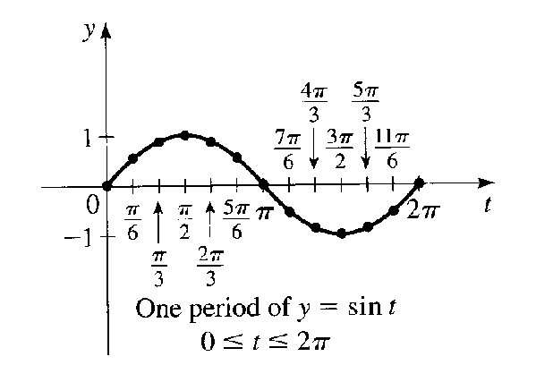
Note: Scan from p. 420 Stewart
t | y = sin t
0 | 0
^{π}/₂ | 1
π | 0
^{3π}/₂ | -1
2π | 0

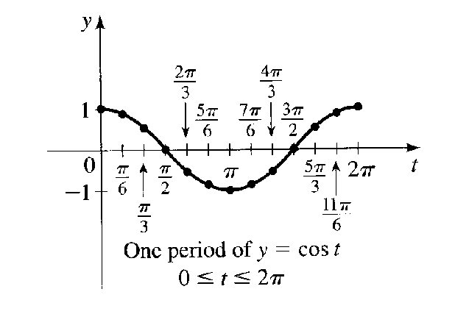
Note: Scan from p. 420 Stewart
t | y = cos t
0 | 1
^{π}/₂ | 0
π | -1
^{3π}/₂ | 0
2π | 1

Notice that I have not included all of the intermediate values in my tables. If you know the general shape of the curve, the basic shape can be drawn based on the minimum and maximum values and a point midway between. As you can see, the function values for sine and cosine are the same values that we see on the unit circle as the y-coordinate for the sine function and as the x-coordinate for the cosine function. The domain of the functions are the values that t can take on. We graph one period of each function where
0 ≤ t ≤ 2π unless otherwise stated.

Next we will investigate the moving of these visual representations of the functions around in space, just as we saw happening with the quadratic function.
If y = f(x) is a function and “a” is a nonzero constant such that f(x) = f(x + a) for every “x” in the domain of f, then f is called a periodic function. The smallest positive constant “a” is called the period of the function, f.

Period Theorem: The period, P, of y = sin(Bx) and y = cos(Bx) is given by
P = 2π
B

The amplitude of a sinusoid is the absolute value of half the difference between the maximum and minimum y-coordinates.

Amplitude Theorem: The amplitude of y = A sin x or y = A cos x is |A|.
Note: The amplitude is the stretching/shrinking translation

The phase shift of the graph of y = sin (x – C) or y = cos(x – C) is C.
Note: The phase shift is the horizontal translation

General Sinusoid:
The graph of: y = A sin (k[x – B]) + C or y = A cos (k[x – B]) + C
Is a sinusoid with: Amplitude = | A |
Period = ^{2π}/_{k}, (k > 0)
Phase Shift = B
Vertical Translation = C

Process For Graphing a Sinusoid Based on Translation
1. Sketch one cycle of y = sin kx or y = cos kx on [0, ^{2π}/_{k}]
a) Change 0, ^{π}/₂, π, ^{3π}/₂, 2π into the appropriate values based on ^{2π}/_{k} and
4 evenly spaced values.
2. Change the amplitude of the cycle according to the value of A
a) Take all general function values of y and multiply them by A
3. If A < 0, reflect the curve about the x-axis
a) Take all values of y from 2a) and make them negative
4. Translate the cycle | B | units to the right if B > 0 and to the left if B < 0
a) Add B to the x-values in 1a)
5. Translate the cycle | C | units upward if C > 0 or downward if C < 0
a) Add C to the y-values in 3a)
Example: Graph y = 2 sin (3[x + ^{π}/₃]) + 1
1. Find the period & compute the 4 evenly spaced points used to graph
y = sin 3x on [0, ^{2π}/₃]
a) The x-values are now 0, (^{2π}/₃ • ¹/₄), (^{2π}/₃ • ¹/₂), (^{2π}/₃ • ³/₄), ^{2π}/₃
or [0, ^{π}/₆, ^{π}/₃, ^{π}/₂, ^{2π}/₃] Note: The multiplication by ¹/₄, ¹/₂ & ³/₄ yields 4 points evenly
space over one period.
2. Find the amplitude & translate the y-values by multiplication
y = 2 sin 3x
a) Sine y-values are usually 0, 1, 0, -1, 0 so now they are 0, 2, 0, -2, 0
3. Investigate any possible reflection
A is positive so no change occurs here.
a) Sine y-values remain as in 2a)
4. Compute the phase shift (horizontal translation) & translate x-values
Note: The phase shift can’t be read until it is written as k[x – B] – this may require a little
algebraic manipulation
y = 2 sin (3[x – (-^{π}/₃)])
a) Add B to x-values in 1a) They were 0, ^{π}/₆, ^{π}/₃, ^{π}/₂, ^{2π}/₃, so
now they are (0 – ^{π}/₃), (^{π}/₆ – ^{π}/₃), (^{π}/₂ – ^{π}/₃), (^{2π}/₃ – ^{π}/₃)
or [-^{π}/₃, - ^{π}/₆, 0, ^{π}/₆, ^{π}/₃]
5. Translate vertically by adding to the last translation of the y-values from
either 2a) or 3a)
y = 2 sin (3[x + ^{π}/₃]) + 1
a) The y-values from 2a) or 3a) have 1 added to them.
They were 0, 2, 0, -2, 0 so they are now 1, 3, 1, -1, 1

This is a table that shows the translations. You would plot the points from the furthest right x & furthest right y.

Plot
⇓
Plot
⇓

t for sin t | t′ for sin 3t | t′′ for sin(3[t – (-^{π}/₃)] | Y for sin t | Y for 2 sin 3t | Y for f(t)
0 | 0 | - π/3 | 0 | 0 | 1
π/2 | π/6 | -π/6 | 1 | 2 | 3
π | π/3 | 0 | 0 | 0 | 1
3π/2 | π/2 | π/6 | -1 | -2 | -1
2π | 2π/3 | π/3 | 0 | 0 | 1

And here is your graph with the translation from y = sin 3x to f(x)
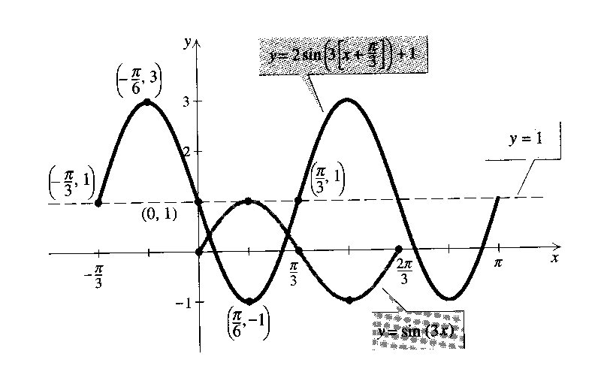

Note: This example is from Precalculus Functions & Graphs and Precalculus with Limits, Mark Dugopolski

Example: a) What translation is being done to y = 3 + sin x?
b) Give a table using the same values of x for y = sin x &
y = 3 + sin x
c) Sketch both sinusoids on the same graph
(Similar #2 p. 429 Stewart)

Example: a) What translation(s) are being done to y = cos 3x?
b) What is the amplitude of the function?
c) What is the period of the function?
d) Give a table using the same values of x for y = cos x &
y = cos 3x
e) Sketch both sinusoids on the same graph

Example: a) What translation(s) are being done to y = 5 sin ¹/₄x?
b) What is the amplitude of the function?
c) What is the period of the function?
d) Give a table using the same values of x for y = cos x &
y = 5 sin ¹/₄x
e) Sketch both sinusoids on the same graph

Example: a) What translation(s) are being done to y = -4 cos ¹/₂(x + ^{π}/₂)?
b) What is the amplitude of the function?
c) What is the period of the function?
d) What is the phase shift?
e) Give a table using the same values of x for y = cos x &
y = -4 cos ¹/₂(x + ^{π}/₂)
f) Sketch both sinusoids on the same graph

Example: You can’t see the period or the phase shift as this function is
currently written. Re-write the function and give the period and
the phase shift. (Adapted from #39 p. 429 Stewart)
y = sin (π + 3x)
Using a Graphing Calculator to View a Sinusoid
1) Find the period, amplitude and phase shift and use these to set the viewing
window (See p. 426 of your text which discusses the dangers of a viewing window that is not
correctly set)
2) Put your calculator in RADIAN mode
3) Use the Y = key to enter the trig function; use X,T, θ, n key for the t value
4) ZOOM trig to graph
5) Use WINDOW to set the view rectangle appropriately

Example: Let’s try this together and at the same time demonstrate 1)
translations and 2) inappropriate viewing rectangle.
a) sin 50x
b) -1 + sin 50x
c) 0.5 sin 50 x
*d) sin 50x – 1

*This is the example that could create havoc if you try to create the wrong viewing window to see all of these at the same time.
§5.4 More Trig Graphs

Next we must learn to graph the other 4 trig f(n). We will start with the tangent and its reciprocal identity the cotangent and then move to the reciprocal identities of sine and cosine.

Recall the Domains:
Tangent {t | t ≠ ^{(2n+1)π}/₂, n ∈ I} (odd multiples of ^{π}/₂ )
Cotangent {t | t ≠ nπ, n∈I} (multiples of ^{π}/₂)

Range:
Tangent & Cotangent (-∞, ∞)

Period: The period, P, of y = a tan(x + π) = a tan kx and
y = a cot(x + π) = a cot kx
is given by
P = ^{π}/_{k}

Amplitude: None exists

Vertical Asymptotes:
Because tan = ^{sin}/_{cos} so as cosine approaches zero (as it gets close to ^{π}/₂•(2n + 1))
tangent will take on infinitely large positive or negative values.

tan x ➜ –∞ as x ➜  ^{π}/₂ ⁺ (the little plus sign above and to the
right means approaches from the right)

tan x ➜ ∞ as x ➜  ^{π}/₂ – (the little minus above and to the right
means approaches from the left)

Because cot = ^{cos}/_{sin} so as sine approaches zero (as it gets close to nπ)
tangent will take on infinitely large positive or negative values.

cot x ➜ ∞ as x ➜  0 ⁺ (the little plus sign above and to the
right means approaches from the right)

cot x ➜ –∞ as x ➜  π – (the little minus above and to the right
means approaches from the left)

Even/Odd Characteristics:
Cosecant is odd like its parent the sine & Secant is even like its parent the cosine
Recall: Symmetric about the origin
When csc (-x) = - csc (x)
Recall: Symmetric about the y-axis
When sec (-x) = sec (x)

Fundamental Cycle:
Tangent (-^{π}/₂, ^{π}/₂)
Cotangent (0, π)

Tables & Graphs:
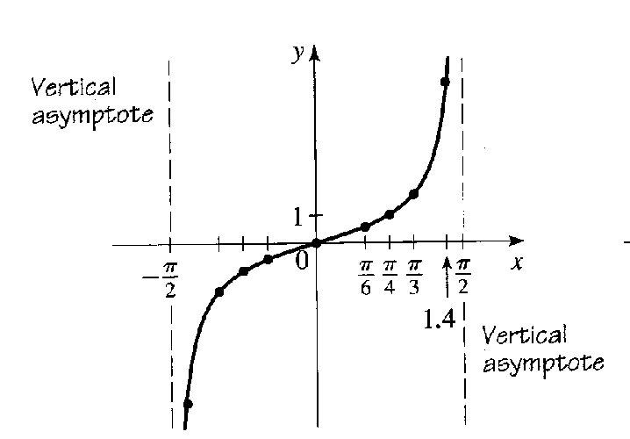
Note: Scan from p. 435 of Stewart
x | y = tan x
– ^{π}/₂ | undefined
– ^{π}/₄ | -1
0 | 0
^{π}/₄ | 1
^{π}/₂ | undefined
* For y = a tan kx use (- ^{π}/_{2k}, ^{π}/_{2k})

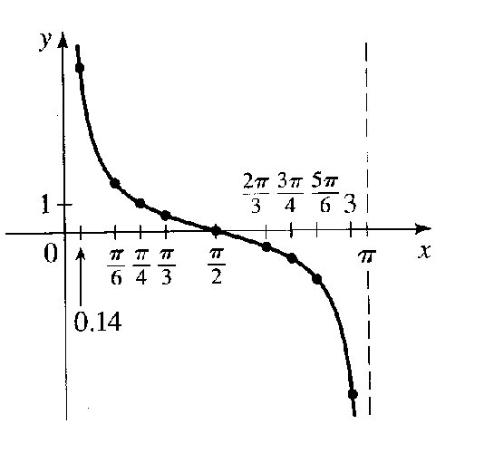
Note: Scan from p. 435 of Stewart

x | y = cot x
0 | undefined
^{π}/₄ | 1
^{π}/₂ | 0
^{3π}/₄ | -1
π | undefined
* For y = a cot kx use (0, ^{π}/_{k})

Tangent and Cotangent functions can have period changes, phase shifts, reflections and vertical translation. Although stretching does occur it is not a change in amplitude.
y = A tan (k[x – B]) + C or y = A cot (k[x – B]) + C
A changes 1 & -1 ➜ A•1 & A• -1 (the y-values)
k changes the period π ➜ ^{π}/_{k}
B changes the values of x used
(-^{π}/₂ + B), (-^{π}/₄ + B), (0 + B), (^{π}/₄ + B), (^{π}/₂ + B) or (0 + B), (^{π}/₄ + B), (^{π}/₂ + B), (^{3π}/₄ + B), (π + B)
C changes 0, 1 & -1 or 0, A•1 & A•-1 ➜
0 + C, 1 + C or 1•A + C & -1 + C or -1•A + C

Note: Asymptotic shifts also occur based on B
(-^{π}/₂ + B) & (^{π}/₂ + B) for tangent and (0 + B) & (π + B) for cotangent

Example: Give a table showing the translation & graph
y = 2 tan x

Example: Give a table showing the translation & graph
y = cot ¹/₂x

Example: Give a table showing the translation & graph
y = – tan (x + ^{π}/₂)

Finally, we will discuss the graphs for the reciprocal identities for sine and cosine.

Recall the Domains:
Cosecant {t | t ≠ nπ, n∈I} (multiples of ^{π}/₂)
Secant {t | t ≠ ^{(2n+1)π}/₂, n ∈ I} (odd multiples of ^{π}/₂ )

Range:
Cosecant & Secant (-∞, -1] ∪ [1, ∞)

Period: The period, P, of y = a csc(x + 2π) = a csc kx and
y = a sec(x + 2π) = a csc kx
is given by
P = ^{2π}/_{k}

Amplitude: None exists

Vertical Asymptotes:
Because csc = ¹/_{sin} so as sine approaches zero (as it gets close to nπ; mult. of π)
cosecant will take on infinitely large positive or negative values.

csc x ➜ ∞ as x ➜  0 ⁺

csc x ➜ ∞ as x ➜  π –

csc x ➜ -∞ as x ➜  π ⁺

csc x ➜ -∞ as x ➜  2π –

Because sec = ¹/_{cos} so as cosine approaches zero (as it gets close to ^{π}/₂(2n + 1); odd mult.
of ^{π}/₂) secant will take on infinitely large positive or negative values.

sec x ➜ ∞ as x ➜  ^{3π}/₂ ⁺

sec x ➜ ∞ as x ➜  ^{π}/₂ –

sec x ➜ -∞ as x ➜  ^{π}/₂ ⁺

sec x ➜ -∞ as x ➜  ^{3π}/₂ –

Even/Odd Characteristics:
Both are odd functions
Recall: Symmetric about the origin
When csc (-x) = - csc (x)
When sec (-x) = - sec (x)

Fundamental Cycle/Primary Interval:
Cosecant (0, 2π)
Secant (0, 2π)

Tables & Graphs:
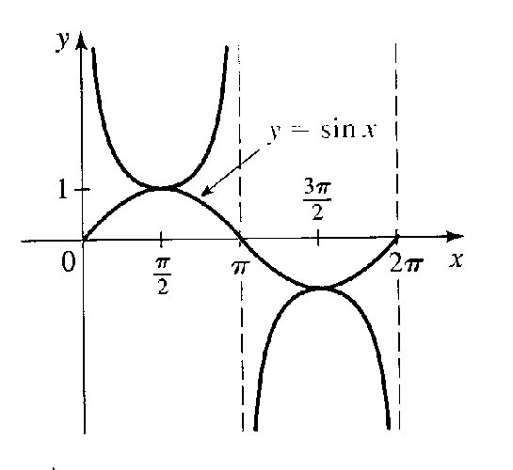
Note: Scan from p. 435 of Stewart
x | y = csc x
0 | undefined
^{π}/₂ | 1
π | undefined
^{3π}/₂ | -1
2π | undefined
* For y = a csc kx use (0, ^{2π}/_{k})

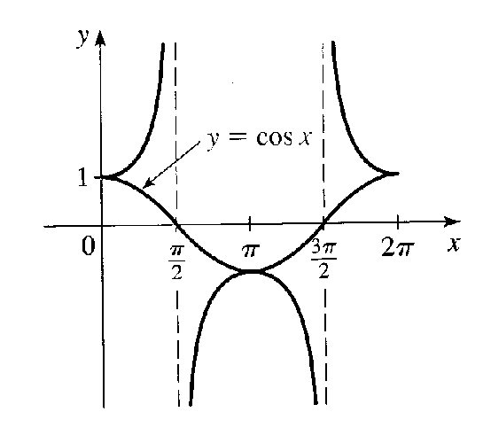
Note: Scan from p. 435 of Stewart
x | y = sec x
0 | 1
^{π}/₂ | undefined
π | -1
^{3π}/₂ | undefined
2π | 1
* For y = a sec kx use (0, ^{2π}/_{k})

Cosecant and Secant functions can have period changes, phase shifts, reflections and vertical translation. Although stretching does occur it is not a change in amplitude.
y = A csc (k[x – B]) + C or y = A sec (k[x – B]) + C
A changes 1 & -1 ➜ A•1 & A• -1 (the y-values)
k changes the period 2π ➜ ^{2π}/_{k}
B changes the values of x used
(0 + B), (^{π}/₂ + B), (π + B), (^{3π}/₂ + B), (2π + B)
C changes 1 & -1 or A•1 & A•-1 ➜ 1 + C or 1•A + C & -1 + C or -1•A + C

Note: Asymptotic shifts also occur based on B
(0 + B) & (π + B) & (2π + B)for cosecant and (^{π}/₂ + B) & (^{3π}/₂ + B) for secant

Example: Give a table showing the translation & graph
y = 2 csc x

Example: Give a table showing the translation & graph
y = sec ¹/₂x

Example: Give a table showing the translation & graph
y = – csc (x + ^{π}/₂)

Note: Section 5.5 is not covered by our course. If you plan on taking a first semester physics course you will study this.

